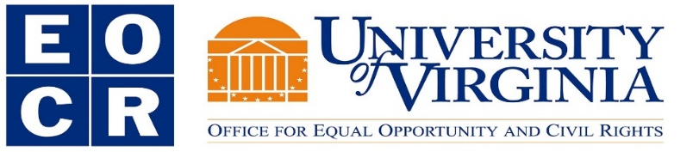

EOCR Response Efforts

The University’s Office for Equal Opportunity and Civil Rights (EOCR) is committed to protecting the civil rights of all University community members through proactive outreach, education, and effective response and resolution. EOCR reviewed the Latinx Student Alliance (LSA) open letter and proposal (“Our University To Shape”) as well as the Asian Leaders Council report (“We Are Not Invisible”). EOCR also attended the Latinx public discussion of “Our University to Shape” in October of 2018 and will continue to seek opportunities to connect with students to listen and learn. Furthermore, EOCR conducted a review of information from the University’s Weldon Cooper Center (based on American Community Survey data) in an effort to understand and support the language diversity in our community. In response to the foregoing information, EOCR plans to take the additional steps outlined below, in alignment with those actions being implemented by other University partners, such as the Office of the Executive Vice President and Provost, Student Affairs, Information Technology, and Human Resources, to support equity and inclusion in our living, learning, and work environment at UVA.

Action Steps

- EOCR is contracting to have all of the policies for which it is responsible, translated:

  - Initial identified priority languages are Spanish, Chinese, and Korean.
  - EOCR is exploring translations in other languages.
  - The translations will be posted on the EOCR website and in the “Related Information” section of the UVA Policy Directory.

- The following statement has been added to the EOCR homepage:
“In an effort to reflect the language diversity of the University community and their families, EOCR is in the process of translating the University policies it is responsible for. EOCR will be posting the translated policies to this website and the University policy directory. In the interim, those who need assistance with translations of EOCR-related policies, please contact us at uvaeocr@virginia.edu and put "Translation Request" in the subject line.”
  - EOCR will also post information regarding vendors for document translation so that such information is readily available to all areas of the University.

- EOCR will be distributing information to the University on obligations related to language assistance.
- EOCR will be contacting UVA-ITS to explore technological tools that may be coded onto University website templates to enhance language translation through existing web tools (e.g., Google Translate).
- EOCR will be updating its recruitment and selection materials and online Employment Equity training to provide additional resources for encouraging identifying opportunities for student participation in faculty search processes and analyzing this participation on a periodic basis.
- EOCR is going to encourage that a preferred qualification of fluency in a language, which aligns with the language diversity analysis, be included in position descriptions for student affairs staff and for other front-facing positions, including student staff positions, that are actively engaged in providing information sessions, tours, and other related functions at the University.
- EOCR, in partnership with the Office of the Provost, will be seeking opportunities to advance systemic support for considering student interest related to developing course offerings.

